# **Abstract**

To get a good understanding of computer methodologies and control mechanisms an inverted pendulum. Which balances itself in an upright position even if any disturbance occurs. In this report, the main focus is to develop a MATLAB/Simulink prototype of a cart inverted pendulum system. The model is acquired using the required mathematical equations and further designed in the MATLAB/Simulink environment.

Furthermore, it provides an insight into getting the maximum efficient control of automation processes using various approaches for instance like computer vision. It also consolidates the use of computational methodologies to a mechatronic device. At the same time, the comprehension of the control mechanism is developed using a methodical process and fuzzy logic, where fuzzy logic provides the most efficient and cost-effective results in comparison to the methodical process.

# **Introduction**

Automatic control is a branch of mathematics and engineering where the desired behaviour of the systems can be obtained by controlling certain parameters that determine the behaviour of the systems both naturally and artificially. Control systems are most commonly found around us in day-to-day life, in the environment and industries.

In the inverted pendulum system, the mass is placed above the pivot point of the pendulum. And as this device is not reliable and must be effectively controlled by horizontal movement of the pivot point that serves as feedback to the device or by quickly upward and downward oscillation to allow for a successful retrospective restoration of the disturbed pendulum.

In non-linear control theory, the most common and difficult issue is swinging up and stabilizing of inverted cart pendulum. The structure and shape of the inverted cart pendulum are identical to real-world objects, such as (segways, ships, arms of robots, rockets, etc.,) therefore the methods used to control can be utilized in several applications. Generally, the single inverted pendulum is categorized into two types: the rotary pendulum, and the cart inverted pendulum**.**In these two systems, the controls are identical, but the drive mechanics are different. The key difference is that the pendulum on the cart device has a limited track distance to be taken into account, particularly during its complexity of swinging.

The device consists of single input and multi outputs, Where the force acts as input and the cart position and angle of the pendulum are outputs. The model is an extremely quasi-dimensional device because of its geometry since the inverted pendulum comprises non-linear terminology and as the system has a pole on the right-hand side of the origin it is a non-minimum phase and underactuated system.

Computer vision is firmly associated with artificial intelligence and allows the computers/ cameras/ sensors to watch and recognize, interpret images, and then perform suitable analysis.

**Literature review of potential designs.**

To understand the design for an inverted pendulum, we first studied some of the related journals and projects. The following is a short literature review on a couple of designs that were referred for our assignment.

One of them was a project by Sherer and Hashimoto (2003), where they used a remote control car to balance the pendulum. For a system to balance a pendulum the primary requirement is to design a base which is able to move quickly in a particular direction in order to counter act the pendulum. So, in this design they used a RC car powered by 12V 1500mA power supply as the cart. An appropriate amount of torque is required by the car for quick transition in motion along with the load of the pendulum. Then they build a small mechanism to support the pendulum (**Sherer and Hashimoto. (2003)).**

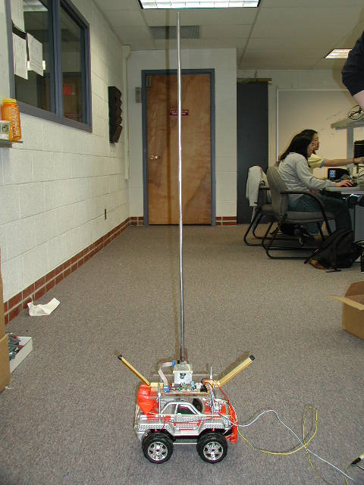

Figure 1: ((**Sherer and Hashimoto. (2003)).**)

Another experiment by Chakraborty (2014) used a DC motor and a belt mechanism to move the cart supporting the pendulum. In their design the cart supporting the pendulum was fixed with wheels but did not have a motor. It was attached to a belt connected to DC motor. The control voltage is given the DC motor and the belt is rotated accordingly to balance the pendulum. (Subudhi, P. and Ghosh (n.d.)).

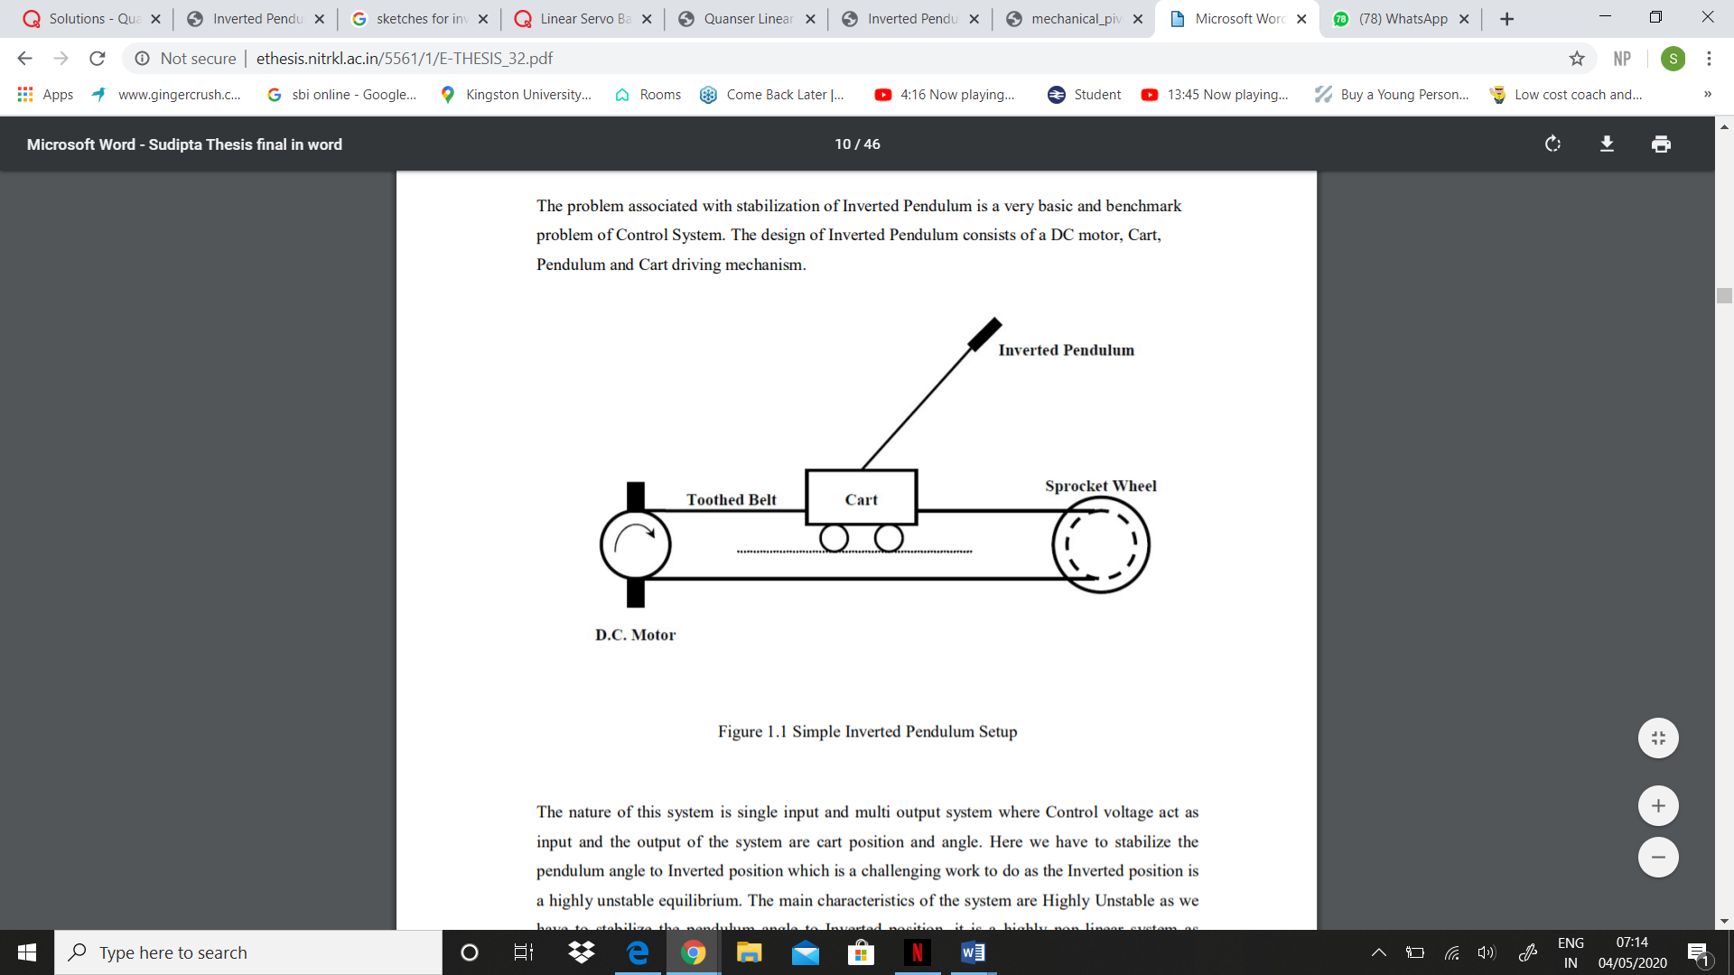

Figure 2: (‌Subudhi, P. and Ghosh (n.d.).)

The (Fig 3) is our finalised design. The DC motot is fixed to the cart supporting the pendulum. It also has and encoder to monitor the position of the cart. They moved about a toothed belt. A rod is passed through the cart for support which keeps the cart in linear motion.

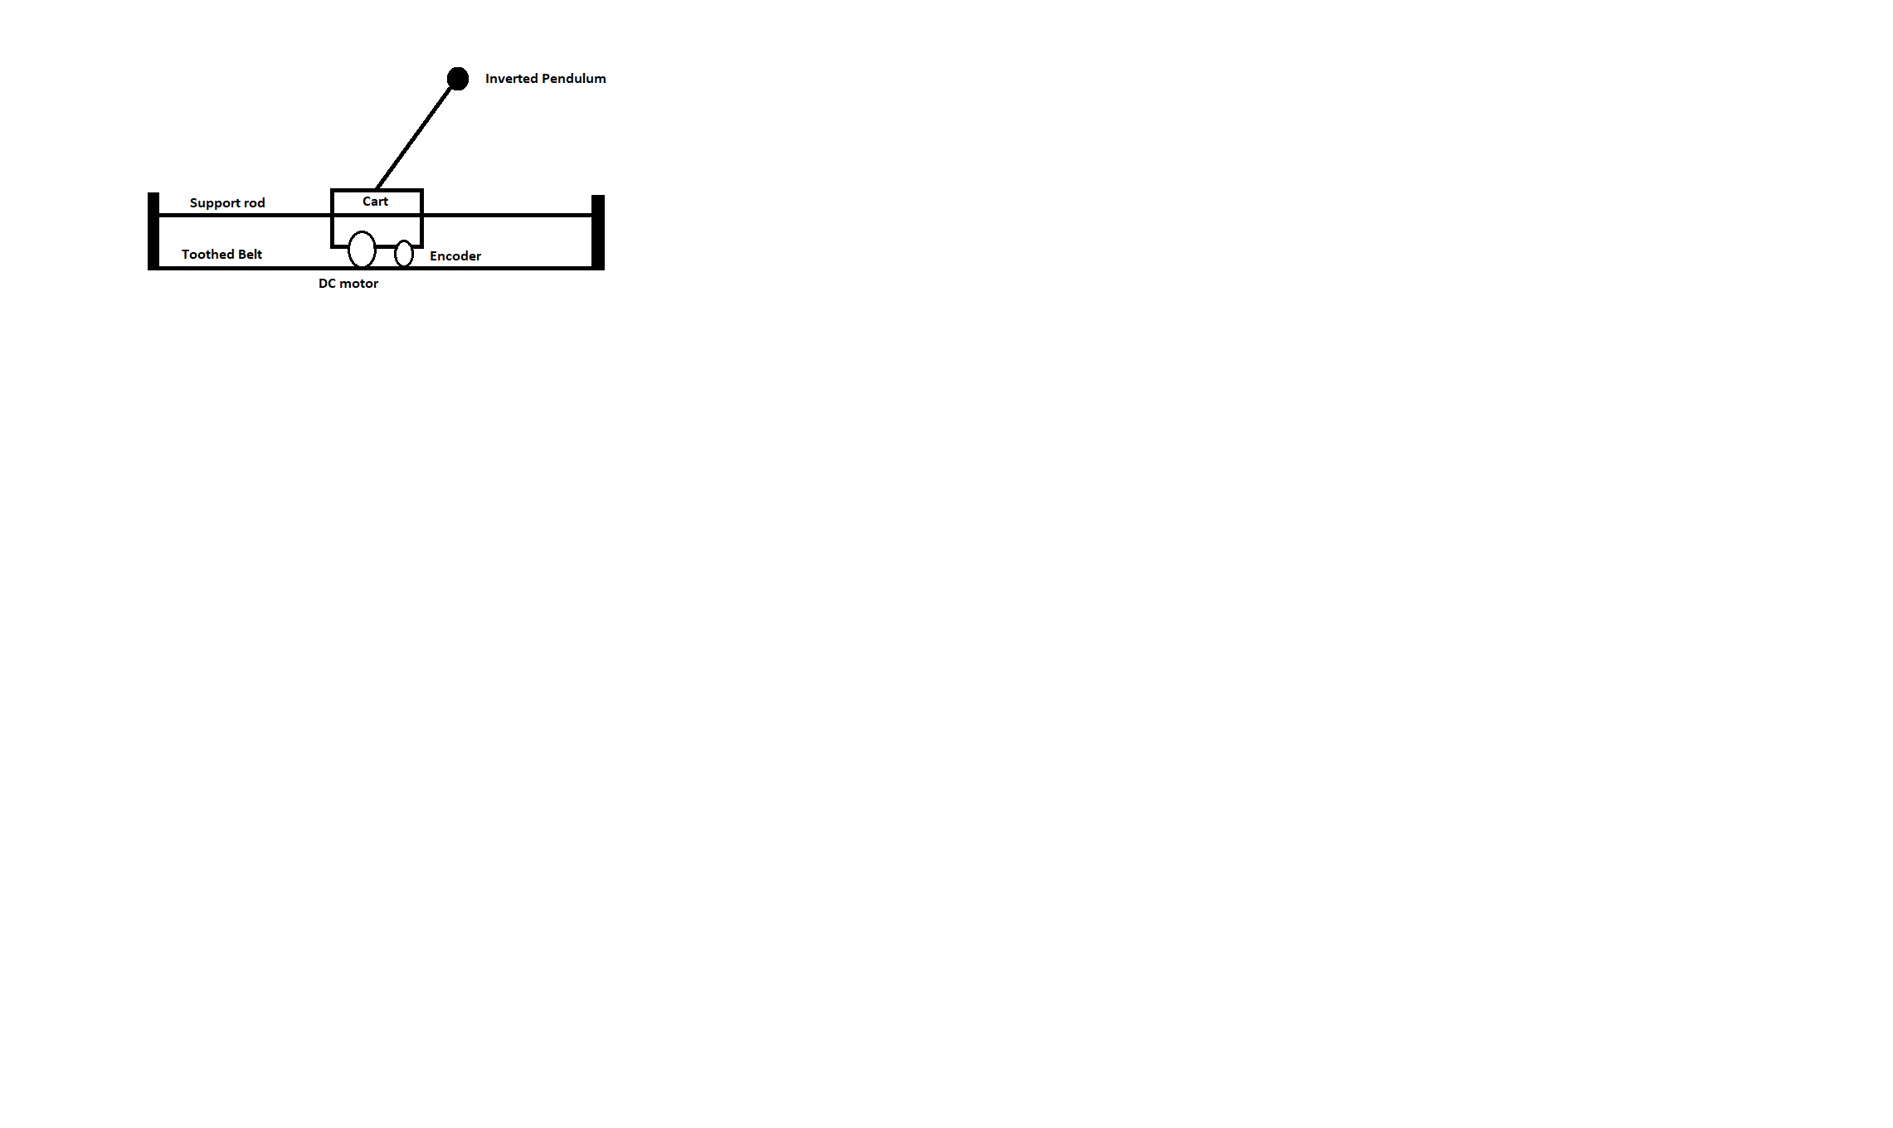

Figure 3: Developed and chosen model for coursework.

A more in-depth description of the dynamics of our system will be explained in the following sections.

# **Kinematics of the system**

The mechanism as seen in Fig.4 consists of a pendulum with mass ‘m’. Which is linked onto the cart mass ‘M’ with a certain angle ‘’. Which can freely move on the x-axis. A force ‘F’ is applied to move the cart horizontally and dynamic equations are necessary to sustain the pendulum in an upright position as the pendulum travels through following the speed-point or preferred path references.

The movement of the pendulum is occurs in the P-N plane. The equilibrium equations for the forces acting on the inverted pendulum are as follows: N andP – mg, where & . The equilibrium of pendulum kinetic action around the center of gravity is defined as

.

The balance of the forces acting on the cart is demonstrated below:

The non-linear system’s dynamic equations are obtained by combining the above equations and is listed below:

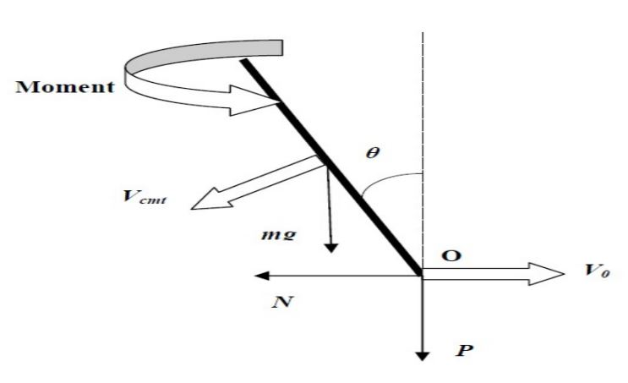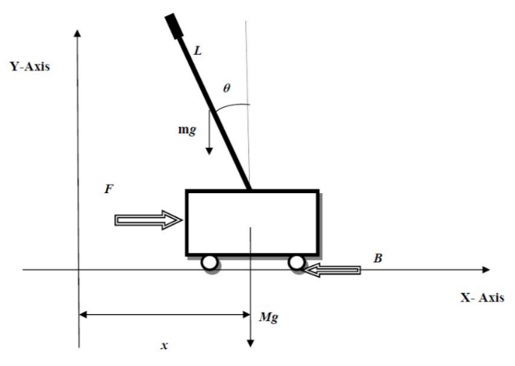

Figure 4: Cart Inverted pendulum free body diagram (Subudhi, P. and Ghosh. 2020)

**Parameter selection**

In this section, we will discuss how the parameters of the pendulum and the cart will affect the working of the overall system. A couple of main parameters to be noted are the length and mass of the pendulum. An increase in the length of the pendulum will subsequently increase the mass of the pendulum. The length of the pendulum should we chose such that it is neither too light nor too heavy. To understand this let us imagine trying to balance a stick on our hand. If the stick is very light or very small, it is harder to balance the sick. But at the same time, the problem with using a heavy pendulum is that its mass is supported by the cart and it will require more force to alternate its position to balance the pendulum. Considering all these appropriate parameters were selected and are displayed in Table 1.

Now looking into the mass of the cart, it is mainly constituted by the mass of the DC motor. The DC motor should be carefully selected such that it can support the pendulum. The DC motor should have enough power to move the cart quickly in the required direction to balance the pendulum. We are using a 6-volt motor with 6000 rpm which is sufficient for our system.

|  |  |  |
| --- | --- | --- |
| **Symbol** | **Description** | **Value** |
| M | Mas/ss | 1.206 Kg |
| B | Co-efficient of friction | 0.005 N*s/m |
| F | Force | - |
| X | Position co-ordinate | - |

Table 1: Parameters of Cart

|  |  |  |
| --- | --- | --- |
| Symbol | Description | Value |
| m | Mass of the pendulum | 0.2693 kg |
| L | Length of the pendulum | 0.1623 m |
| I | Moment of inertia of pendulum | 0.099 Kg/m2 |
| D | Damping coefficient of pendulum | 0.005 mm/rad |
| g | Gravity | 9.81 m/s2 |

Table 2: Parameters of Pendulum

# **Modelling**

The Inverted cart pendulum consists of 1 degree of freedom (DOF): The position of the cart denoted as ‘**x**’ and ‘**θ**’ represents the pendulum angle. The device is an under-actuated system since the user has only one controllable variable ‘**Force F’**applied to the cart, therefore the arbitrary trajectories of the two-state variables are tough to attain. The rationalized ICP models, which are commonly used for the simulation may neglect the real-time acting effects such as friction and other physical limits like voltage from an amplifier, DC motor’s capacity.

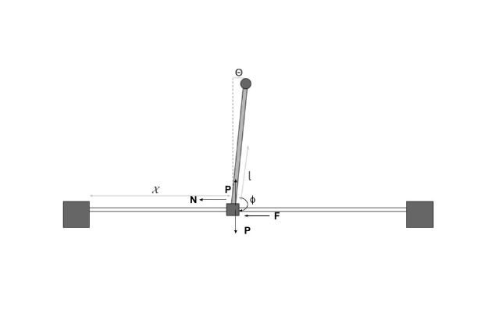

Figure 5: Cart Inverted pendulum (Sbresny,2020.)

Using the Newtons Second law of motion (F = ma), the differential equations for the degrees of freedom were obtained.

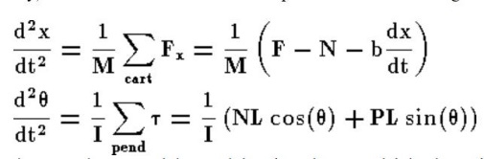

Equation 1(lost-contact.mit.edu, 2020)

To represent the dynamics of the system the interaction forces ‘**N**’ & ‘**P**’ were implemented. In addition to its theta dynamics, the addition of these forces needs the pendulum's x and y dynamics to be modelled. And the simulation is performed using the Simulink. As and are accurate theta variables. Thus, in terms of theta derivatives, we can describe their derivatives.

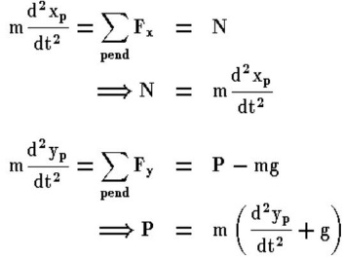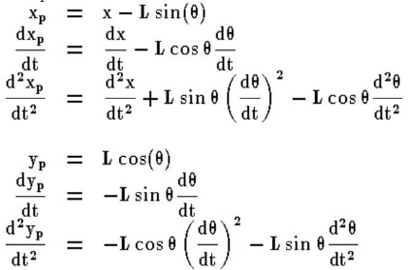

Equation 2 (lost-contact.mit.edu, 2020)

Finally, the obtained equations are substituted in the extracted interaction forces ‘N’ & ‘P’. Where ‘N’ is the horizontal reaction force and ‘P’ is the vertical reaction force.

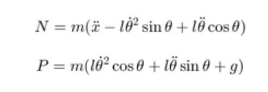

Equation 3 (ctms.engin.umich.edu, 2020)

# **Task 4**

**Construction:**

In Simulink-Matlab, SimMechanics is a toolbox to model the dynamics of multibody structures. SimMechanics is focused on the simulation of an entity and related block diagrams models or mechanical structures are developed. Using the SimMechanics/ Simscape multibody blocks a physical component can be created with required dimensions and kinematic relations.  Nevertheless, the system of SimScape can be easily incorporated with standard blocks of Simulink. This allows a SimScape model to be built in a specific setting under the Simulink control framework.

The modelling of the Cart Inverted pendulum is completed in the Simulink environment using the Simscape multibody tools. All the required blocks are called up into the Simulink modelling environment and the gravity value of is specified in the mechanism configuration and the damping coefficient is set to 0.005mm/rad in prismatic cart block under internal mechanics.

Later on, the cart and the pendulum blocks are inserted with the specific dimensions, and the axis of the cart and the pendulum are set using the rigid transform block. The revolute action of the pendulum is set up using the revolute pendulum block. And all the connections are made according to the required setup of cart inverted pendulum. (refer to Fig.7)

A subsystem (Fig.6) named ‘wrap angle’ is developed to obtain the angle conversion of the pendulum and is connected to the cart inverted pendulum model as shown in Fig.7. After connecting all the blocks and simulating the system the output of the cart inverted pendulum is shown in Graph.1. As seen in the Fig.8 the pendulum was not quite robust and not in the upright position.

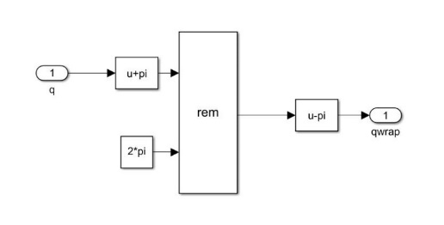

Figure 6: Subsystem

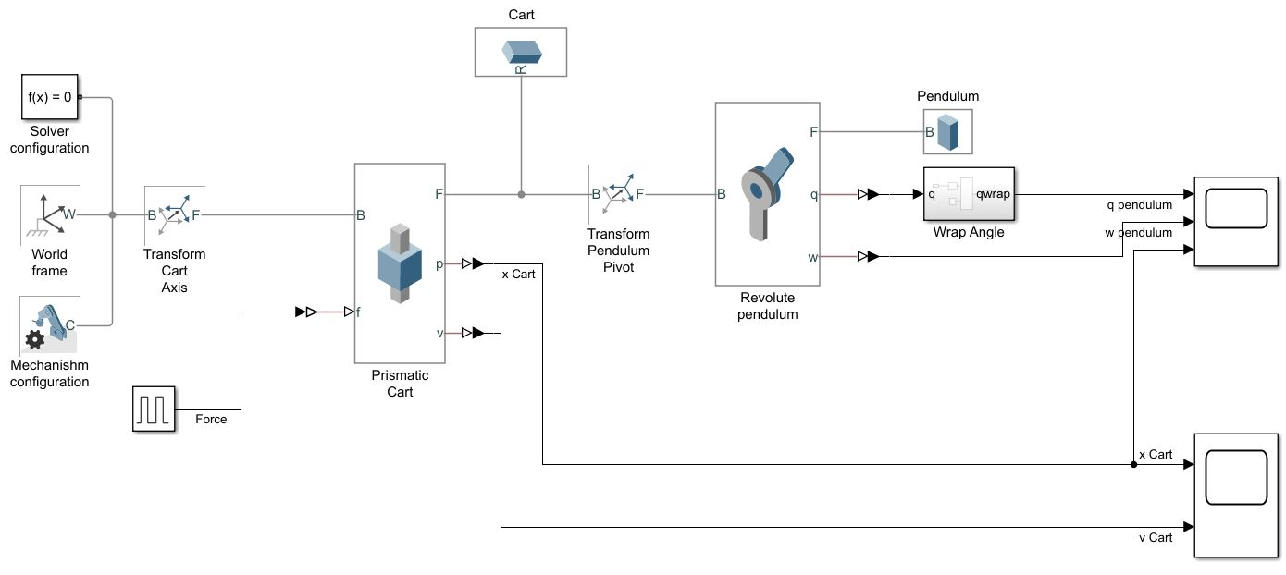

Figure 7: Cart inverted pendulum model

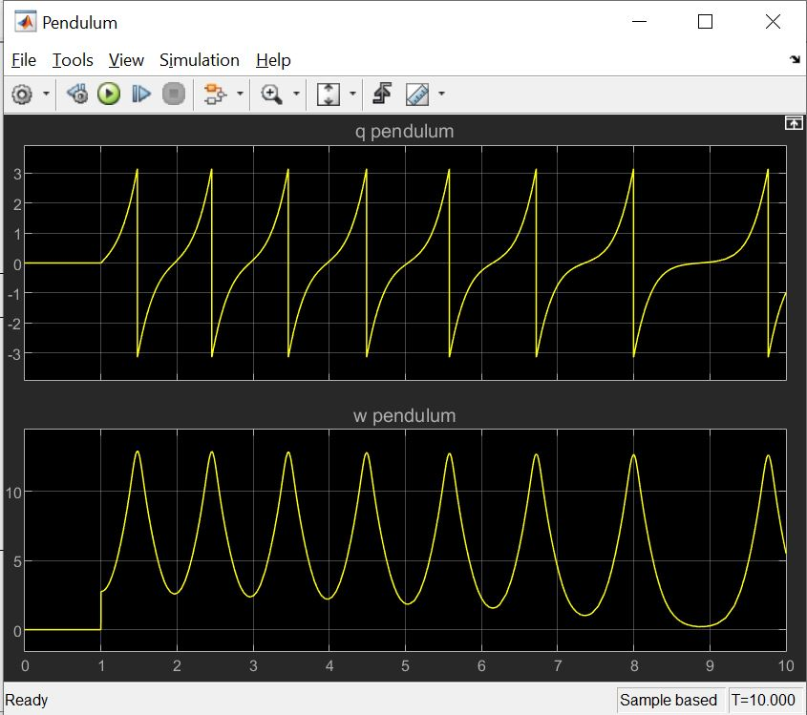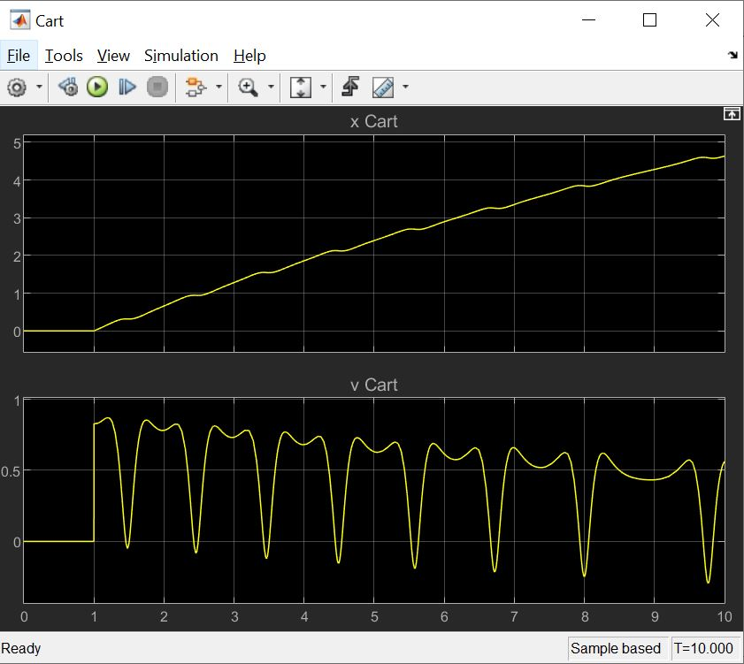

Graph 1: Disturbance of pendulum and cart.

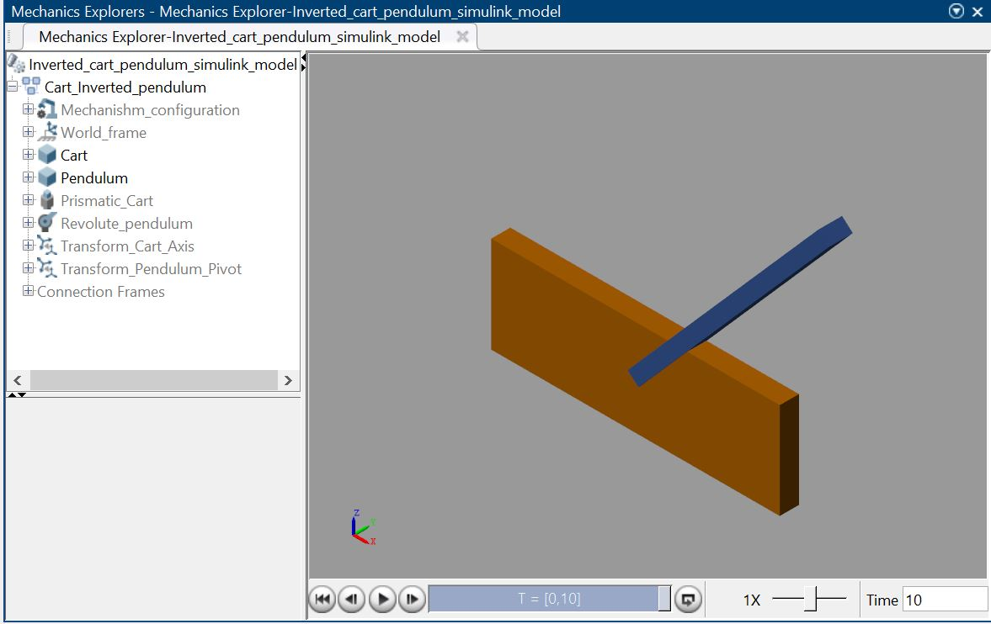

Figure 8: Pendulum without PID controller

As the cart inverted pendulum model is not quite stable a PID controller is connected to the model to convert it into a robust system as shown in Fig.10. And the PID controller connection is made using a manual switch to check the comparisons of the system.

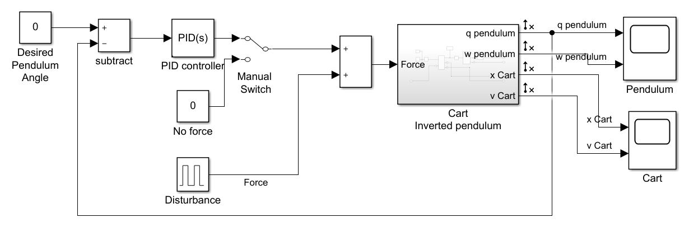

Figure 9: Cart inverted pendulum Simulink model

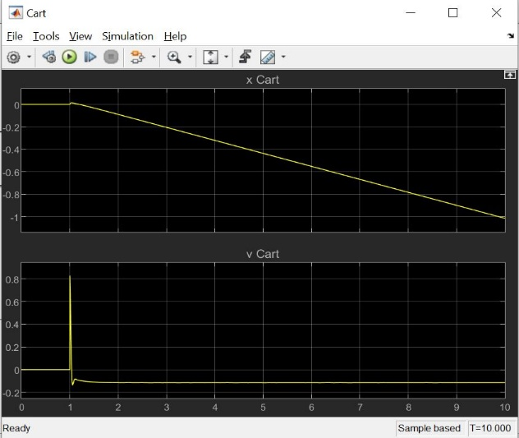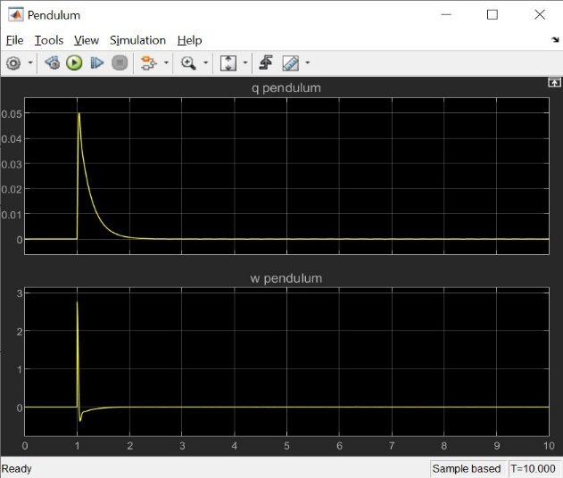

Graph 2: Graphs After Implementing PID Controller

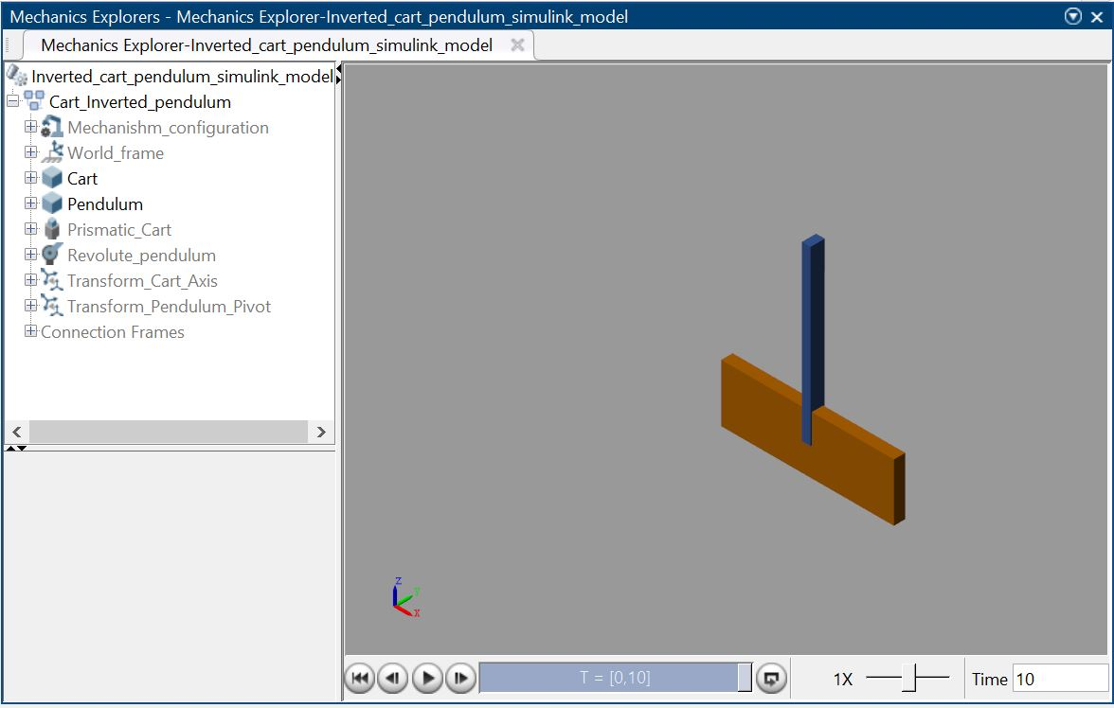

Figure 10: Cart inverted pendulum after PID implementation

# References

**Sherer and Hashimoto. (2003). Inverted Pendulum Balancer. [online] Available at: https://people.ece.cornell.edu/land/courses/ece4760/FinalProjects/s2003/es89kh98/es89kh98/index.htm [Accessed 4 May 2020].**

‌Subudhi, P. and Ghosh (n.d.). *An Experimental study for Stabilization of Inverted Pendulum Under the Guidance of*. [online] Available at: <http://ethesis.nitrkl.ac.in/5561/1/E-THESIS_32.pdf>.

Sbresny, Richard & Getler, Andrew & Felker, Nick & Frederickson, Chris. (2016). Implementation of an Inverted Pendulum PID Control System Using a Stepper Motor. 10.13140/RG.2.2.34564.12164. (Accessed on: 29 April 2020)

<https://lost-contact.mit.edu/afs/umich.edu/class/ctms/Public/html/simulink/examples/pend/pendsim.htm>

<http://ctms.engin.umich.edu/CTMS/index.php?example=InvertedPendulum&section=SystemModeling>